# TS7960 – DRIVER PER MOTORI C.C. + ESP32

ll driver TS7960 per motori da 43A utilizza due mosfet BTS7960 per pilotare motori con assorbimento fno a 43A.    
Il driver e protetto contro il surriscaldamento, la sovracorrente, la sovratemperatura e il corto circuito.  
Il pilotaggio dei mosfet BTS7960 è effettuato tramite un 74HC244 in modo da isolare il circuito di controllo dal circuito di potenza.  
  
Caratteristiche:

* Tensione di alimentazione da 6Vcc a 27Vcc
* Tensione di controllo da 3,3Vcc a 5Vcc
* Corrente massima di lavoro 43A a 24Vcc

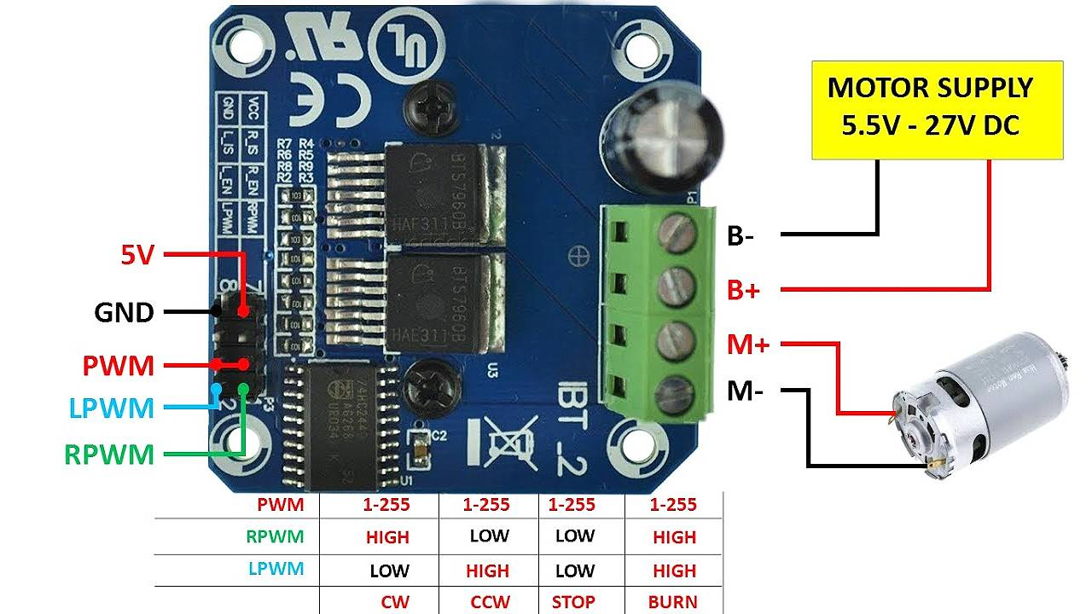

## Applicazioni

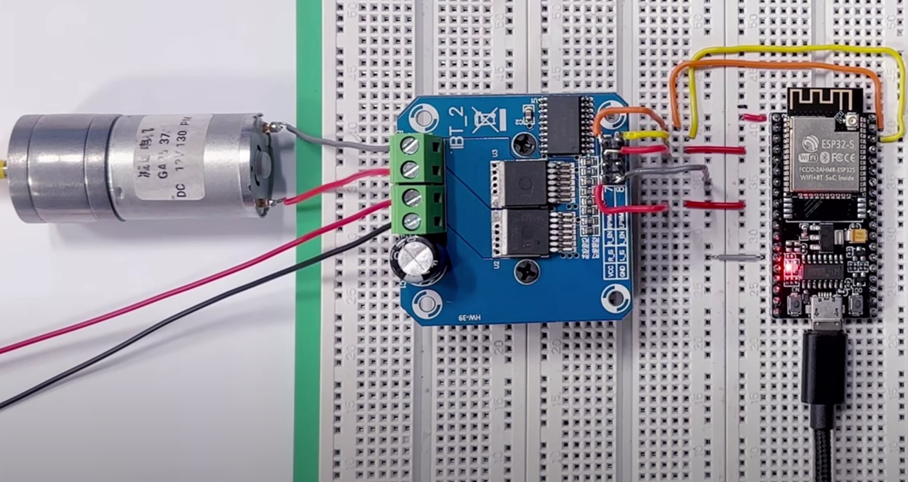

12 V

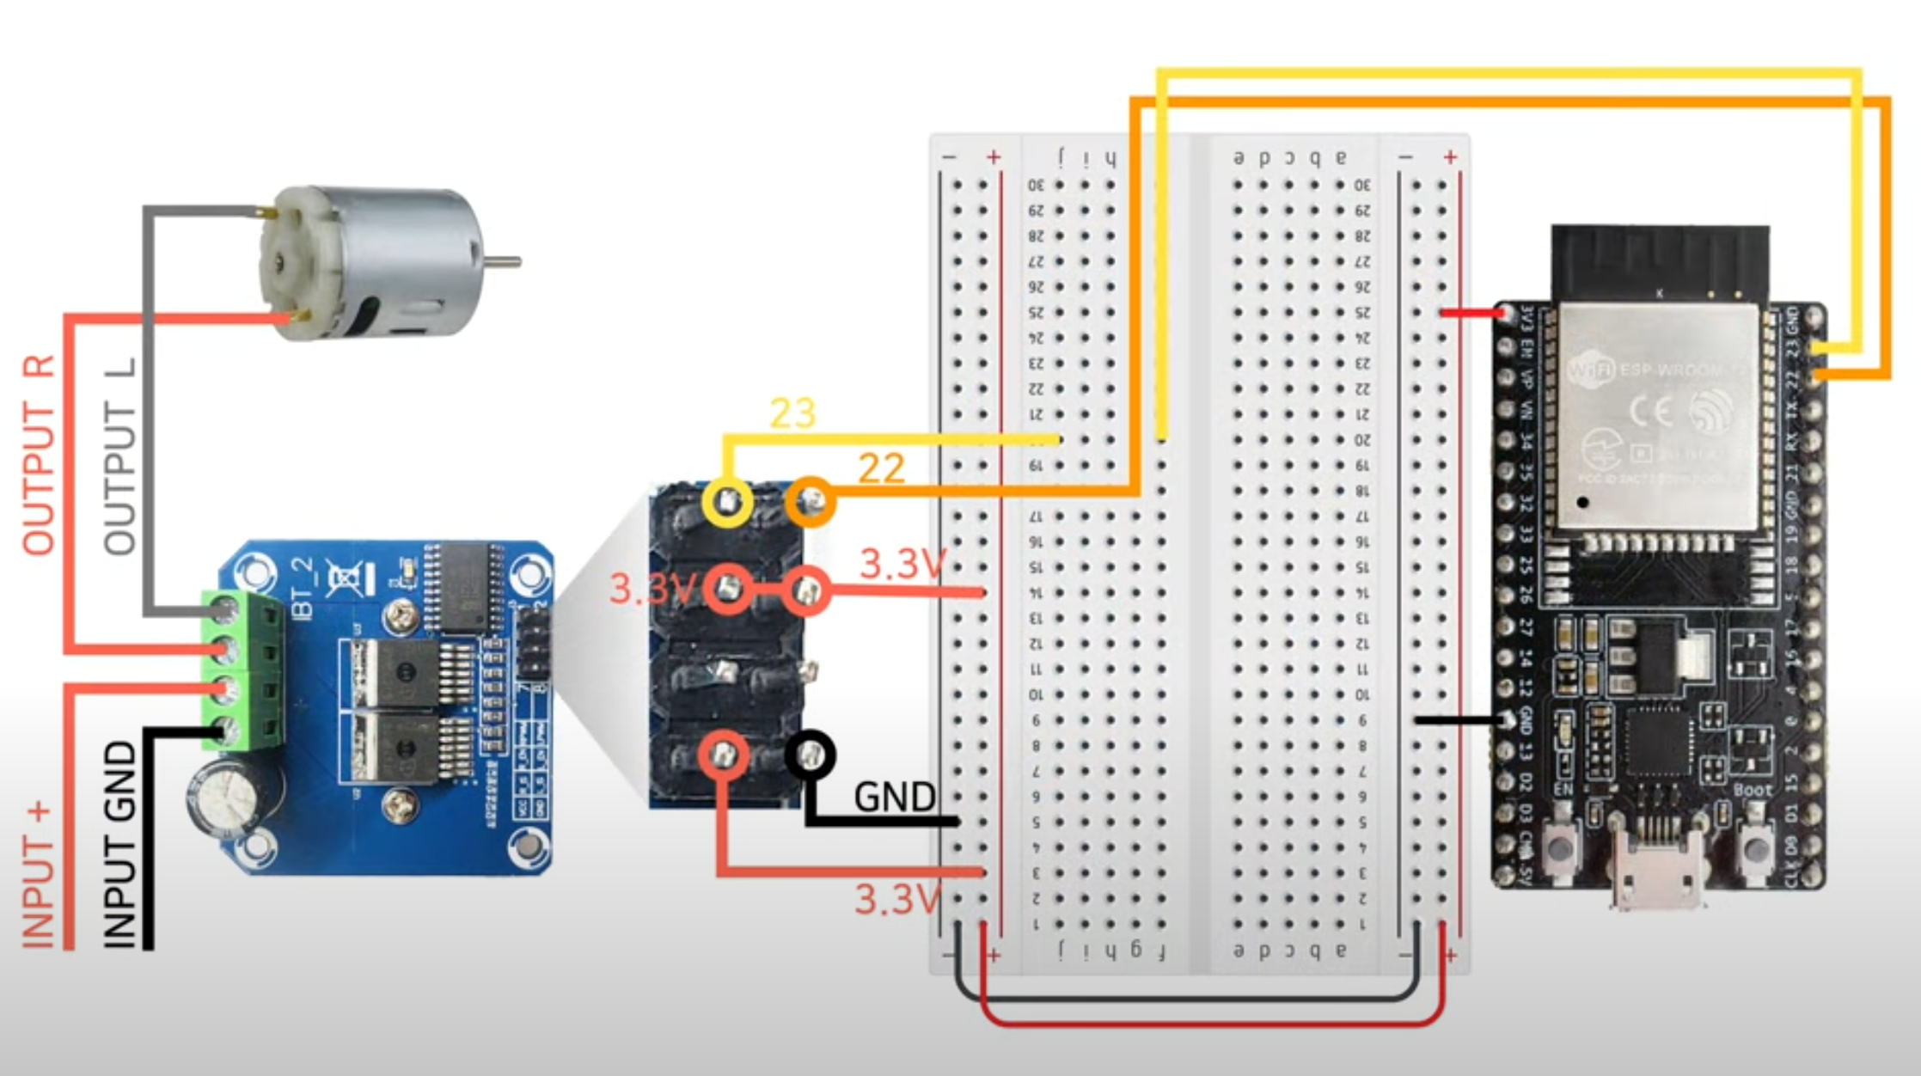

12 V

## Codice

const int motor_R = 9;

const int motor_L = 10;

void setup() {

}

void loop() {

analogWrite(motor_L, 0);

delay(500);

for(int i=0; i<255; i++) {

analogWrite(motor_R, i);

delay(30);

}

analogWrite(motor_R, 0);

delay(500);

for(int i=0; i<255; i++) {

analogWrite(motor_L, i);

delay(30);

}

}

/////////////////////////////////////////////////////////////////////////////////////////////////////////////////////////////////

int RPWM=5;  
int LPWM=6;  
// timer 0  
int L_EN=7;  
int R_EN=8;  
  
void setup() {  
  // put your setup code here, to run once:  
  for(int i=5;i<9;i++){  
   pinMode(i,OUTPUT);  
  }  
   for(int i=5;i<9;i++){  
   digitalWrite(i,LOW);  
  }  
   delay(1000);  
    Serial.begin(9600);  
  }  
  
  
  
void loop() {  
  // put your main code here, to run repeatedly:  
  Serial.println("EN High");  
  digitalWrite(R_EN,HIGH);  
  digitalWrite(L_EN,HIGH);  
delay(1000);  
for(int i=0;i<256;i++){  
  analogWrite(RPWM,i);  
//  analogWrite(LPWM,255-i);  
  delay(100);  
}  
delay(500);  
for(int i=255;i>0;i--){  
  analogWrite(RPWM,i);  
// analogWrite(LPWM,255-i);  
  delay(100);  
}  
delay(500);  
Serial.println("EN LOW");  
digitalWrite(R_EN,LOW);  
  digitalWrite(L_EN,LOW);  
delay(1000);  
for(int i=0;i<256;i++){  
  analogWrite(RPWM,i);  
  delay(100);  
}  
delay(500);  
for(int i=255;i>0;i--){  
  analogWrite(RPWM,i);  
  delay(100);  
}  
delay(500);  
}  
  
  
The PWM Frequency on the arduino UNO Atmega328p - Timer0 is 970Hz ,   
This is a low PWM Frequency , in the next step we want to increase PWM Frequency to get a more smoothly control of the motor.  
  
Arduino Uno atmega 328p MCU has 3 timers , Time0,,Time2 8 Bit and Time1 16Bit  .  
Timer0 is connected to pin D5 , D6  , we want to increase the frequency "More smoothly control "   
  
Note That Timer0 is control the  (delay , millis ) on the arduino , so any change on the prescale of this timer will change the delay and millis time .  
  
int RPWM=5;  
int LPWM=6;  
int L_EN=7;  
int R_EN=8;  
  
  void setPWMfrequency(int freq){  
   TCCR0B = TCCR0B & 0b11111000 | freq ;  
  }  
   
  void MotorActiveStatus(char Side,boolean s){  
    boolean state=s;  
    if(Side=='R'){  
    digitalWrite(R_EN,s);  
    }  
    if(Side=='L'){  
    digitalWrite(L_EN,s);  
    }      
  }  
  void setMotor(char side,byte pwm){  
   if(side=='R'){  
    analogWrite(RPWM,pwm);  
   }  
    if(side=='L'){  
    analogWrite(LPWM,pwm);  
   }  
  }  
  void closeMotor(char side){  
     if(side=='R'){  
    digitalWrite(RPWM,LOW);  
     }  
     if(side=='L'){  
    digitalWrite(LPWM,LOW);  
     }  
  
     }

void setup() {  
  // put your setup code here, to run once:  
  setPWMfrequency(0x02);// timer 0 , 3.92KHz  
  for(int i=5;i<9;i++){  
   pinMode(i,OUTPUT);  
  }  
   for(int i=5;i<9;i++){  
   digitalWrite(i,LOW);  
  }  
   delay(1000);  
   MotorActiveStatus('R',true);  
   MotorActiveStatus('L',true);  
    Serial.begin(9600);  
  }  
  
void loop() {  
  // put your main code here, to run repeatedly:  
for(int i=0;i<256;i++){  
  setMotor('R',i);  
  delay(500);  
}  
delay(1000);  
closeMotor('R');  
delay(1000);  
  for(int i=0;i<256;i++){  
  setMotor('L',i);  
  delay(500);  
}  
delay(1000);  
closeMotor('L');  
delay(1000);  
}  
  
if we want to use this code with another timer " timer 2 " just change  D5 , D6 To pin D3 , D11 Respectively  
  
int RPWM=3;  
int LPWM=11;  
int L_EN=7;  
int R_EN=8;  
  
  void setPWMfrequency(int freq){  
   TCCR2B = TCCR2B & 0b11111000 | freq ;  
  }  
   
  void MotorActiveStatus(char Side,boolean s){  
    boolean state=s;  
    if(Side=='R'){  
    digitalWrite(R_EN,s);  
    }  
    if(Side=='L'){  
    digitalWrite(L_EN,s);  
    }      
  }  
  void setMotor(char side,byte pwm){  
   if(side=='R'){  
    analogWrite(RPWM,pwm);  
   }  
    if(side=='L'){  
    analogWrite(LPWM,pwm);  
   }  
  }  
  void closeMotor(char side){  
     if(side=='R'){  
    digitalWrite(RPWM,LOW);  
     }  
     if(side=='L'){  
    digitalWrite(LPWM,LOW);  
     }  
  
     }  
void setup() {  
  // put your setup code here, to run once:  
  setPWMfrequency(0x02);// timer 2 , 3.92KHz  
  for(int i=5;i<9;i++){  
   pinMode(i,OUTPUT);  
  }  
   for(int i=5;i<9;i++){  
   digitalWrite(i,LOW);  
  }  
   delay(1000);  
   MotorActiveStatus('R',true);  
   MotorActiveStatus('L',true);  
    Serial.begin(9600);  
  }  
  
void loop() {  
  // put your main code here, to run repeatedly:  
for(int i=0;i<256;i++){  
  setMotor('R',i);  
  delay(50);  
}  
delay(500);  
closeMotor('R');  
delay(1000);  
  for(int i=0;i<256;i++){  
  setMotor('L',i);  
  delay(50);  
}  
delay(500);  
closeMotor('L');  
delay(1000);  
}